**Excel to pdf file converter using Java**

**Project name- ExcelToPDFConverter**

**Src>> package_name-converter**

**Package_name >>class_name- ExcelToPDFConverter**

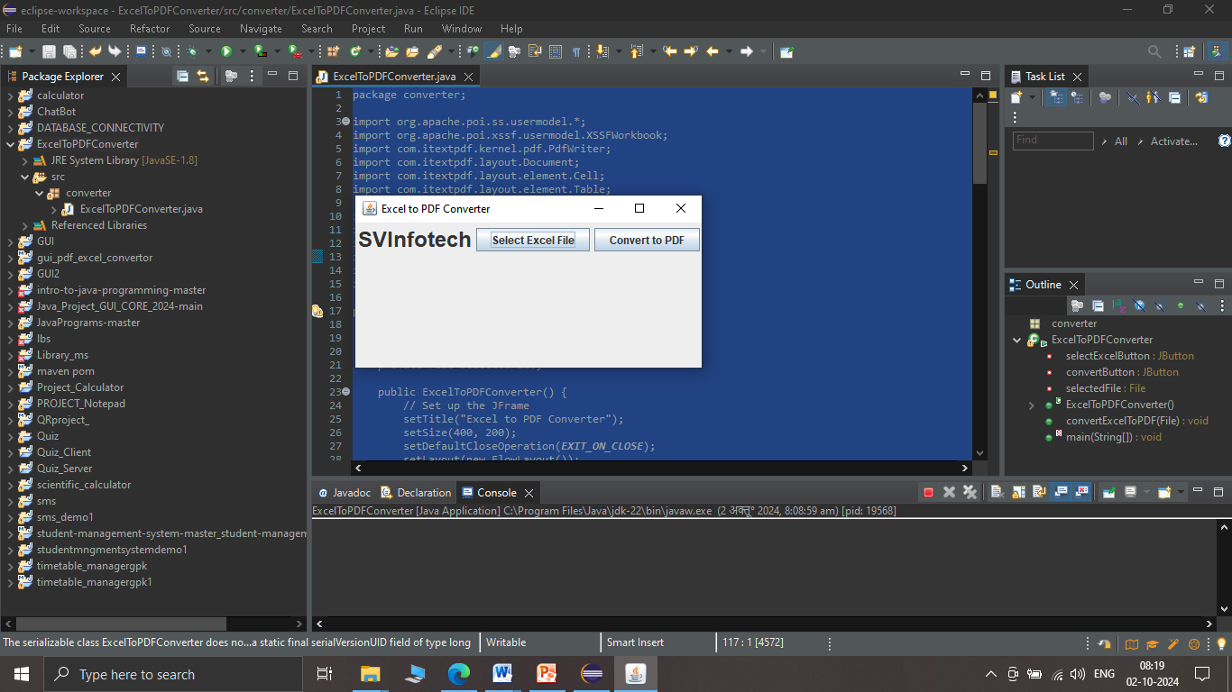

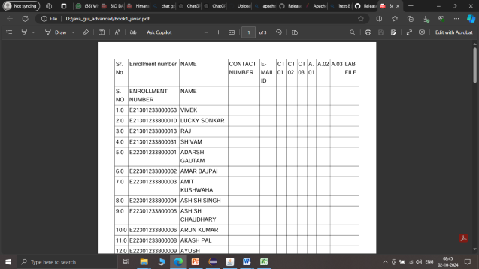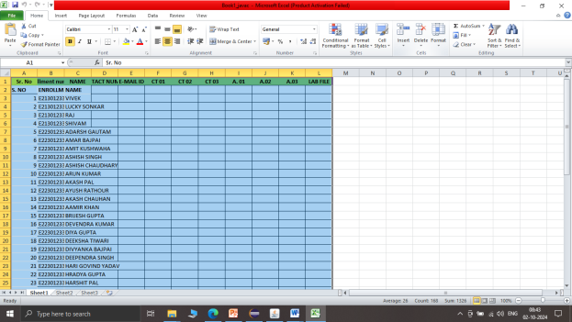

**(Excel file) (pdf file)**

**Source code:**

**package converter;**

**import org.apache.poi.ss.usermodel.*;**

**import org.apache.poi.xssf.usermodel.XSSFWorkbook;**

**import com.itextpdf.kernel.pdf.PdfWriter;**

**import com.itextpdf.layout.Document;**

**import com.itextpdf.layout.element.Cell;**

**import com.itextpdf.layout.element.Table;**

**import javax.swing.*;**

**import java.awt.*;**

**import java.awt.Font;**

**import java.awt.event.ActionEvent;**

**import java.awt.event.ActionListener;**

**import java.io.*;**

**public class ExcelToPDFConverter extends JFrame**

**{**

**private JButton selectExcelButton;**

**private JButton convertButton;**

**private File selectedFile;**

**public ExcelToPDFConverter()**

**{**

**// Set up the JFrame**

**setTitle("Excel to PDF Converter by svinfotech himanshu singh");**

**setSize(400, 200);**

**setDefaultCloseOperation(EXIT_ON_CLOSE);**

**setLayout(new FlowLayout());**

**// Create and add title label**

**JLabel titleLabel = new JLabel("SVInfotech");**

**titleLabel.setFont(new Font("Arial", Font.BOLD, 24));**

**// Set font and size**

**titleLabel.setHorizontalAlignment(SwingConstants.CENTER);**

**// Center the text**

**add(titleLabel);**

**// Create and add buttons**

**selectExcelButton = new JButton("Select Excel File");**

**convertButton = new JButton("Convert to PDF");**

**add(selectExcelButton);**

**add(convertButton);**

**// Button to select an Excel file**

**selectExcelButton.addActionListener(new ActionListener()**

**{**

**@Override**

**public void actionPerformed(ActionEvent e)**

**{**

**JFileChooser fileChooser = new JFileChooser();**

**int result = fileChooser.showOpenDialog(null);**

**if (result == JFileChooser.APPROVE_OPTION) {**

**selectedFile = fileChooser.getSelectedFile();**

**JOptionPane.showMessageDialog(null, "Selected File: " + selectedFile.getName());**

**}**

**}**

**});**

**// Button to convert the selected Excel file to PDF**

**convertButton.addActionListener(new ActionListener()**

**{**

**@Override**

**public void actionPerformed(ActionEvent e)**

**{**

**if (selectedFile != null) {**

**try {**

**convertExcelToPDF(selectedFile);**

**JOptionPane.showMessageDialog(null, "Conversion Successful!");**

**} catch (Exception ex) {**

**JOptionPane.showMessageDialog(null, "Error during conversion: " + ex.getMessage());**

**}**

**} else {**

**JOptionPane.showMessageDialog(null, "Please select an Excel file first.");**

**}**

**}**

**});**

**}**

**public void convertExcelToPDF(File excelFile) throws Exception**

**{**

**// Load the Excel workbook**

**FileInputStream fis = new FileInputStream(excelFile);**

**Workbook workbook = new XSSFWorkbook(fis);**

**Sheet sheet = workbook.getSheetAt(0);**

**// Create a new PDF document**

**String pdfFileName = excelFile.getAbsolutePath().replace(".xlsx", ".pdf");**

**PdfWriter writer = new PdfWriter(pdfFileName);**

**com.itextpdf.kernel.pdf.PdfDocument pdfDoc = new com.itextpdf.kernel.pdf.PdfDocument(writer);**

**Document document = new Document(pdfDoc);**

**// Create a table with the number of columns equal to the number of columns in the first row of the Excel sheet**

**int numberOfColumns = sheet.getRow(0).getPhysicalNumberOfCells();**

**Table table = new Table(numberOfColumns);**

**// Iterate over rows and cells to add data to the PDF table**

**for (int rowIndex = 0; rowIndex <= sheet.getLastRowNum(); rowIndex++) {**

**Row row = sheet.getRow(rowIndex);**

**if (row != null) {**

**for (int colIndex = 0; colIndex < row.getPhysicalNumberOfCells(); colIndex++) {**

**Cell cell = new Cell().add(new com.itextpdf.layout.element.Paragraph(row.getCell(colIndex).toString()));**

**table.addCell(cell);**

**}**

**}**

**}**

**// Add the table to the PDF document**

**document.add(table);**

**// Close the workbook and the document**

**workbook.close();**

**document.close();**

**}**

**public static void main(String[] args) {**

**// Run the GUI application**

**SwingUtilities.invokeLater(() -> {**

**ExcelToPDFConverter converter = new ExcelToPDFConverter();**

**converter.setVisible(true);**

**});**

**}**

**}**

**Create this project in eclipse ide:**

**Run this project with alt+shift+x**

**Add jar files of apache poi version 5 and itext version 8**

**Link to download jar files:**

**Poi jar files-**

[**https://dlcdn.apache.org/poi/release/src/apache-poi-src-5.3.0-20240625.zip**](https://dlcdn.apache.org/poi/release/src/apache-poi-src-5.3.0-20240625.zip)

**above are for excel files.**

**itext jar files-**

[**https://github.com/itext/itext-java/releases/download/8.0.5/iText-Core-8.0.5-only-jars.zip**](https://github.com/itext/itext-java/releases/download/8.0.5/iText-Core-8.0.5-only-jars.zip)

**above are for pdf files.**

**How to add external jars in project:**

**Right click on project from project explorer>>build path>>configure build path>>select libraries tab>>add external jar>>select jars>> click apply >> click apply and close**